**Circuit diagram:**

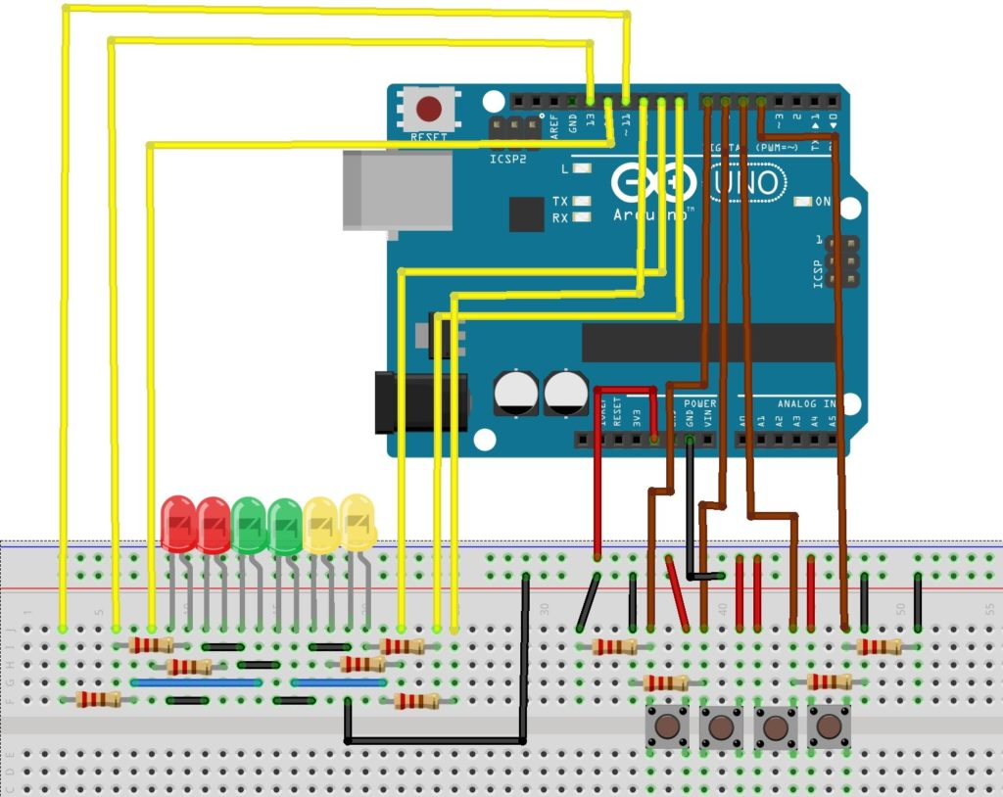

**Theory:**

**Concept used:** To design a led chaser using arduino.

**Learning and Observation:**

We learnt to design a traffic light using arduino.firstly at pin Mode 0 we used red led and after blinking for 1 sec, at pin Mode 1 we used yellow led and lastly at pin Mode 2 we used green led.

**Precautions:**

1. Connections should be tight.

2. Test the led before blinking

3. Led should be directly connected to power supply.

**Learning outcomes**

1. Design traffic lights.

2. Home decorations.

3. Blinking light in bicycles.